**Maximum sum of hour glass**

Given two integers **n**, **m** and a 2D matrix **mat** of dimensions **nxm**, the task is to find the **maximum sum** of an **hourglass**.  
An **hourglass** is defined as a part of the matrix with the following form:

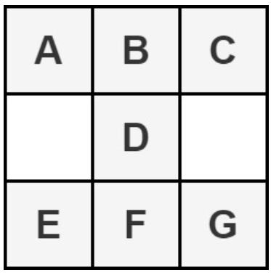

Return **-1** if any hourglass is **not found**.

**Example 1:**

**Input:**

n = 3, m = 3

mat = [[1, 2, 3],  
 [4, 5, 6],  
 [7, 8, 9]]

**Output:**

35

**Explanation:**

There is only one hour glass which is

1 2 3

5

7 8 9 and its sum is 35.

**Example 2:**

**Input:**

n = 2, m = 3

mat = [[1, 2, 3],  
 [4, 5, 6]]

**Output:**

-1

**Explanation:**

There are no hour glasses in this matrix.

**Your Task:**  
You don't need to read input or print anything. Your task is to complete the function **findMaxSum()** which takes the two integers **n**, **m**, and the 2D matrix **mat** as input parameters and returns the maximum sum of an hourglass in the matrix. If there are no hourglasses, it returns -1.

**Expected Time Complexity:**O(n*m)  
**Expected Auxillary Space:**O(1)

**Constraints:**1 <= n <= 1503 <= m <= 150  
0 <= mat[i][j] <= 106

Code :

class Solution {

public:

int findMaxSum(int n, int m, vector<vector<int>> mat) {

int maxSum = -1;

for(int i=1; i<n-1; i++) {

for(int j=1; j<m-1; j++) {

int sum = mat[i][j]+mat[i-1][j]+mat[i+1][j]+

mat[i-1][j-1]+mat[i-1][j+1]+mat[i+1][j-1]+

mat[i+1][j+1];

maxSum= max(maxSum, sum);

}

}

return maxSum;

}

};

Link : https://www.geeksforgeeks.org/problems/maximum-sum-of-hour-glass3842/1